**Boolean Circuits**

**- User Manual**

Table of contents

1. Introduction3

1.1 The application3

2. Understanding the GUI3

2.1 Menu3

2.2 Toolbar4

2.3 Palette4

2.4 Center stage4

2.5 Pop up menu5

3. Functionality5

3.1 Workspace5

3.2 Saving, opening and importing files5

3.3 Build circuit6

3.4 Edit circuit6

3.5 Running circuit7

3.6 Graphical representation settings7

4. Script language7

5. Credits8

**1. Introduction**   
  
**1.1 The application**  
Boolean circuits  is primarily for educational purposes targeting students studying fundamentals of digital systems and computers or anyone else interested in the subject. This application allows the user to build circuits consisting of logic gates and simulate them in real time.  
  
This is a simple manual designed for a new user to get up to speed with Boolean Circuits. After reading this anyone should be able to start working on circuits.  
  
**2. Understanding the GUI**  
This section explains the user interface of Boolean Circuits.  
  
**2.1 Menu**

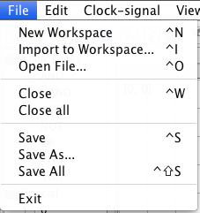  
In *File menu* you execute the following operations:

* New Workspace - Creates a new workspace.
* Import to Workspace - Imports a previously saved workspace into currently active workspace.
* Open File - Opens a previously saved workspace.
* Close - Closes the currently active workspace.
* Close all - Closes all opened workspace.
* Save - Saves currently active workspace if changes has been done
* Save As - Saves currently active workspace which has not been saved before.
* Save All - Saves all workspaces currently opened to which changes has been done.
* Exit - Exit application.

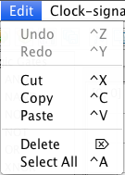  
  
In *Edit menu* you execute the following operations:

* Cut - Cuts selected components, with connections, to later be pasted on to active workspace.
* Copy - Copies selected components, with connections, to later be pasted on to active workspace.
* Paste - Pastes previously copied components to active workspace..
* Delete - Removes selected gate from workspace.
* Select All - Selects all components on active workspace.

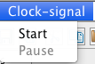  
  
In *Clock signal menu* you execute the following operations:

* Start - Starts clock pulse on active workspace.
* Pause - Pauses clock pulse on active workspace.

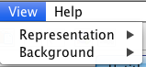  
  
In *View menu* you execute the following operations:

* Representation - User can choose between  IEC Standard or US Standard to represent logic gates.
* Background - User can choose between blank, dotted or grid background.

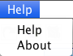In *Help menu* user can execute the following operations:

* Help - Shows this document, the user manual.
* About - Shows all information about Boolean Circuits such as creators of the application and Icon sources.

**2.2 Toolbar**   
The toolbar provides shortcuts to actions in the menu bar. It contains operations that you may want fast access to. All operations in the toolbar has a corresponding keyboard shortcut to minimize excise.

**Skärmavbild 2011-05-18 kl. 14.28.31.png**

The toolbar found below the menu.

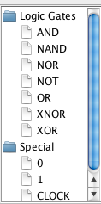

**2.3 Palette**  
A tree structure is located at the left side of the application. This tree structure is called the palette, which contains all the basic logic gates, 2 constant gates and a clock pulse generator. Here you select a component, by clicking on it, so that you can place it in your circuit.

**2.4 Center stage**  
The center stage contains all opened work spaces. For every new workspace a new tab with a canvas is created. Unsaved workspaces are marked with an asterisk in front of the name of the workspace. Each tab is a graphical representation of a workspace, where the user can place and connect logic gates.

The palette.

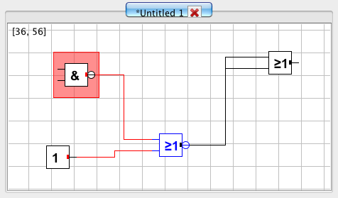

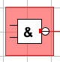

A red square surrounding gate indicates that the inputs of the gate has not been properly connected.

Center stage with tab and canvas. Canvas contains a graphical representation of a circuit.

**2.5 Pop up menu**  
The pop up menu appears when user clicks right mouse button on canvas. The pop up menu will change appearance if the user clicks on a component instead of directly on the canvas. When clicking right mouse button on a component the pop up menu  will represent operations on the component. When clicking the right mouse button on an empty space the pop up menu will represent operations on the circuitry as a whole.  
  
**3. Functionality**   
This segment will explain how to use  before mentioned operations.  
  
**3.1 Workspace**  
To create a new, blank, workspace, press the new workspace button or Ctrl+N. If you want to close the active workspace, press the corresponding button in the menu or Ctrl+W.  
  
**3.2 Saving, opening and importing files**  
You can save a newly created workspace by either clicking the save button in toolbar or save button in file menu, alternatively Ctrl+S. A file manager will then be shown and you save the active workspace by first choosing which location to save the file in, then clicking the save button of the file manager window. To save all open workspaces, press the save all button or Ctrl + Shift + S.  
  
If changes has been made to a workspace an asterisk will be shown alongside the name of the workspace. In the event of closing a workspace or the program, you will be prompted if you want to save eventually changed workspace(s).

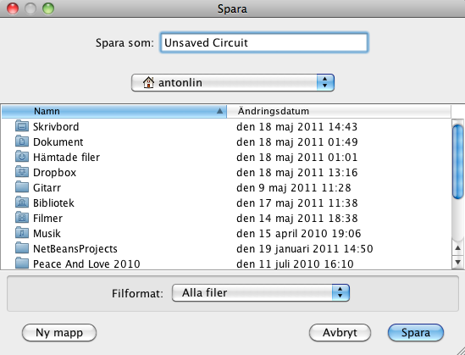

The file chooser displayed when saving a newly created workspace.

To open a file you can either press the open file button in the toolbar or file menu, alternatively Ctrl + O. A file manager will then be shown and user will have to select which file to open.  
  
To import a file to an already opened workspace you click the import workspace button or press Ctrl + I. A file manager will be shown and user will have to select which previously saved workspace to import. The components in the file will be inserted in the currently active workspace.  
  
**3.3 Build circuit**  
When building a circuit user has mainly two commands available, add component and connect component. To add a component to workspace first select a component in palette. When component has been selected double click on preferred location on canvas and component will be added.   
  
To connect components, right click preferred component on canvas. The pop up menu will be shown and user can choose to either connect *output* or *input* to another component.

* 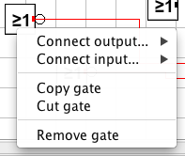To connect *output* - Select output to connect. Right click on the component which the selected output should be connected to. The pop up menu will appear and user can now select which input to connect the output to.

* To connect *input* - select which input to connect. Right click on the component which the selected input should be connected to. The pop up menu will appear and user can now select which output to connect the input to.

**3.4 Edit circuit**  
There are a number of operations available to edit a circuit:

* 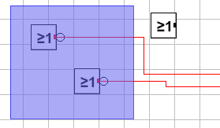Select - To select one component. Left click mouse button on preferred component. To select multiple components, use Shift + left mouse button to either select preferred components one by one or drag mouse from empty space on canvas and a selection square will appear. All components within the selection square will be selected when left mouse button is released.

The selection square depicted above.

* Move component - Hold down left mouse button over preferred component and drag. Component will now be moved.
* Delete - Select which component to delete and press delete button on keyboard or right click on preferred component. The pop up menu will appear, then select the remove gate option.
* Copy - Select which components to copy. Then press the copy button or keyboard shortcut Ctrl + c.
* Cut - Select which components to cut. Then press the cut button or keyboard shortcut Ctrl+x. Component will be copied and then deleted from workspace.
* Paste - Right click on preferred location on canvas. The pop up menu will appear, choose paste option and previously copied/cut component will be pasted on to canvas or use keyboard shortcut Ctrl+v.

Skärmavbild 2011-05-18 kl. 15.09.28.pngSkärmavbild 2011-05-18 kl. 15.09.43.png  
  
**3.5 Running circuit**   
When clock has been connected to circuit press run clock button to run circuit. To pause circuit press pause clock button.

From left to right: when paused and when running.

**3.6 Graphical representation settings**  
In the view menu you can edit the graphical representation in Boolean Circuits. You can change the background between blank, dotted and a grid.

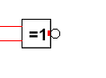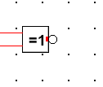

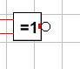

Depicted above the three different background options. From left to right: blank, grid and dotted.

User can also choose if logic gates should be represented in IEC standard or US standard by selecting one of them.

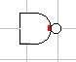Skärmavbild 2011-05-18 kl. 15.13.17.png

A NAND gate in IEC standard(left) and US standard(right).

**4. Script language**  
When saving a workspace, all of the components and connections of the circuit found within the workspace is saved into a file without file-extension. The script language of Boolean Circuits will be found in this file and can easily be manually altered or opened with another software. Since it is a fairly simple script language you could easily create your own circuits by learning the script syntax.  
  
The script language consists of two commands:*add*and *connect*. These are the only commands the user will need to build her own circuit.   
  
When *adding* a component on to workspace you will have to type in the following:

* What type of command. In this case “ADD”.
* What type of logic gate. For example “AND”.
* Number of inputs.
* Number of outputs.
* The X-coordinate of the components position.
* The Y-coordinate of the components position.

When *connecting* components the user will have to type in following:

* What type of command. In this case connect which is written “CNCT”.
* Index of the component that is receiving the connection.
* Index of the input of the receiving component.
* Index of the component that is sending out the connection.
* Index of the output of the sender component.

This example of a save file adds three components, and makes two connections between them:  
ADD 0 0 1 48 145  
ADD NOT 1 1 48 81  
ADD OR 2 1 209 112  
CNCT 2 0 0 0  
CNCT 2 1 1 0  
  
**5. Credits**  
Boolean Circuits is developed by Robert Kaufmann, Anton Lin, Boel Nelson and Jennifer Panditha at Chalmers university of technology. It is published under GNU GPL v3.  
  
**Icon sources**  
Save, Undo, Redo, Open  
*VisualPharm.com*  
  
Import circuit, Cut, Copy, Paste, Play Clock, Pause Clock  
*www.iconarchive.com/artist/fatcow.html*  
  
Cross  
*www.iconarchive.com/artist/yusuke-kamiyamane.html*